**061306T4CSC**

# COMPUTER SCIENTIST LEVEL 6

**ICT/OS/CS/CR/10/6/A**

**DEMONSTRATE WEB DESIGN SKILLS**

**Nov. /Dec. 2022**



**THE KENYA NATIONAL EXAMINATIONS COUNCIL**

**PRACTICAL ASSESSMENT**

**Time: 3 HOURS**

**INSTRUCTIONS TO CANDIDATE**

1. You are required to have a working Personal Computer with the following tools installed:
   1. Web Browser
   2. Text Editor
2. You are required to have a copy of JQuery Library
3. This paper consists of **TWO** tasks. Perform **ALL** the tasks.

**This paper consists of THREE (3) printed pages**

**Candidates should check the question paper to ascertain that all pages are printed as indicated and that no questions are missing**

**TASK 1**

Create the form below.

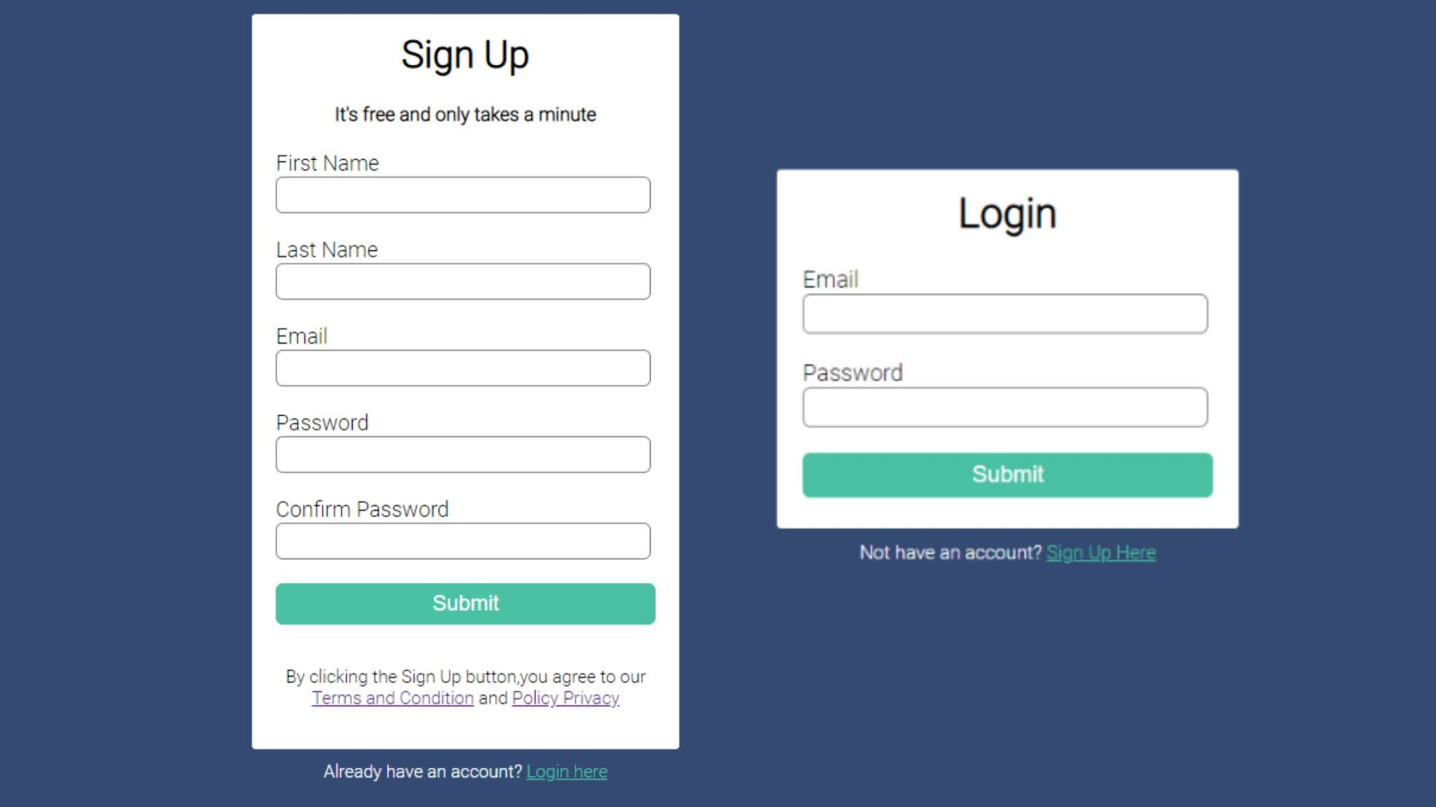

**TASK 2**

* + - * 1. Create the form below.



* + - * 1. Write JQuery code to validate the login details before the form is submitted. The validation code should be able to:

Check that the email:

* Has a username which consists of alphanumeric characters of not more than 20 characters;
* Contains the @ symbol;
* Has an appropriate domain name e.g. Gmail; and
* Has an extension of between 2 and 3 characters e.g. .com.

Check that the password:

* Is at least 8 characters long;
* Contains
  + At least one uppercase character;
  + a special character; and
  + a digit.

Generate appropriate error messages for each invalid input and display it in an appropriate form element below the input element being validated.

Clear and hide the form element containing the error message in case valid input is made.

Delete all dynamically created elements and allow form submission.

**THIS IS THE LAST PRINTED PAGE.**